IOPS COUNTRY PROFILE: AUSTRALIA

|  |  |  |  |  |  |  |  |  |  |  |  |  |  |
| --- | --- | --- | --- | --- | --- | --- | --- | --- | --- | --- | --- | --- | --- |
|  | **DEMOGRAPHICS AND MACROECONOMICS**   |  |  | | --- | --- | | GDP per capita (USD)1 | **71 862** | | Population (000s)2 | **26 639** | | Labour force (000s)2 | **14 041** | | Employment rate2 | **96.5** | | Population over 65(%)2 | **17.1** | | Dependency ratio3 | **32.4** |  1. Source: OECD, calculated on a PPP basis, 2023 calendar year. 2. Source: Australian Bureau of Statistics, as at 30 June 2023. 3. Source: Australian Bureau of Statistics, ratio of over 65-year-olds, June 2023 / labour force, June 2023. |

# AUSTRALIA: COUNTRY PENSION DESIGN

**STRUCTURE OF THE PENSION SYSTEM**

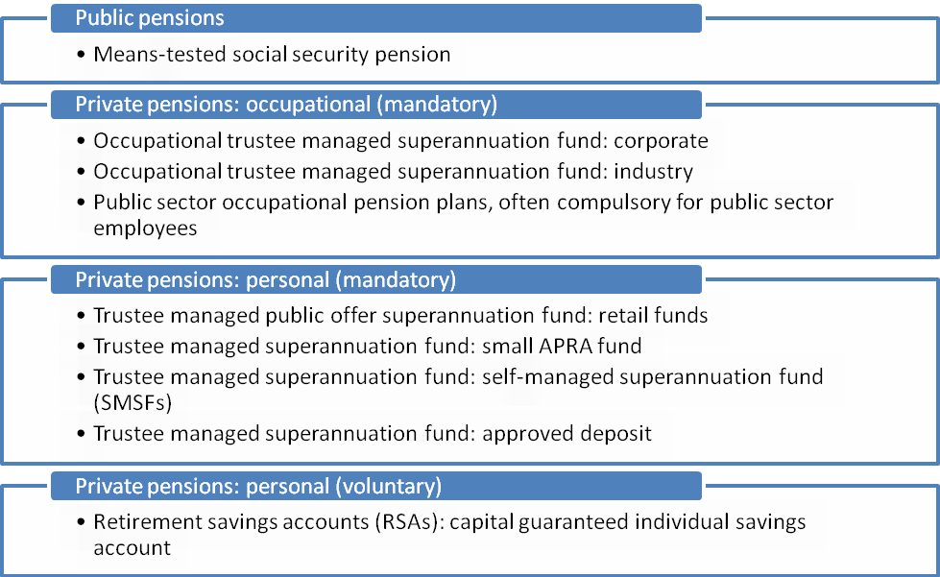

Source: OECD/IOPS Global Pension Statistic

# AUSTRALIA: THE PENSION SYSTEM’S KEY CHARACTERISTICS PUBLIC PENSION

The cost of the public pension - known as the Age Pension - is solely covered by Australian Government’s general revenue (i.e. there are no social security contributions in Australia). The eligibility age for men and women is currently:

* 65 years and 6 months, if born between 1 July 1952 and 31 December 1953;
* 66 years, if born between 1 January 1954 and 30 June 1955;
* 66 years and 6 months, if born between 1 July 1955 and 31 December 1956; and
* 67 years, if born on or after 1 January 1957.

Individuals must have been an Australian resident for at least 10 years, with five of those years being continuous. However, some individuals are exempt from this rule, for example, refugees or former refugees. Income and assets tests are applied to target the pension to those with limited means. The maximum Age Pension benefit is AUS $1,116.30 per fortnight for a single person, and AUS $841.40 per fortnight for each member of a couple. The value of the Age Pension is adjusted biannually to increases in prices and wages.

**OCCUPATIONAL/PERSONAL MANDATORY**

*Coverage*

Employers must pay superannuation contributions for all eligible employed persons who are 18 years or over. An employer must also pay if an individual is under 18 and is working more than 30 hours per week. Self-employed individuals participate on a voluntary basis.

*Contributions*

For the financial year ending 30 June 2024, the required contribution is 11 per cent of Ordinary Time Earnings (OTE) up to a maximum of AUS $62,270 OTE per quarter (this maximum superannuation contributions base is indexed in line with Average Weekly OTE each income year). This is paid solely by employers, although employees may make voluntary contributions. From 1 July 2021, concessional contributions, including employer and personal voluntary contributions, are subject to an annual cap of AUS $27,500. From 1 July 2018, individuals with a total superannuation balance of less than AUS $500,000 are also able to make ‘catch-up’ superannuation contributions by carrying forward unused concessional cap space amounts. These unused caps can be used on a rolling basis for a period of five years.

From 1 July 2022, individuals under the age of 75 are able to make non-concessional contributions into their superannuation funds up to an annual cap of AUS $110,000 and are also eligible to bring forward up to three years of non-concessional contributions. Individuals with a balance of AUS $1.7 million or over will no longer be able to make non-concessional contributions.

The Government provides a contribution up to AUS $500 to eligible individuals with taxable incomes up to AUS $37,000, to effectively refund the contributions tax their superannuation funds pay on their concessional contributions. This is through the Low Income Superannuation Tax Offset (LISTO).

The Government also offers a tax offset to individuals who make contributions to the superannuation of their low-income spouses. From 1 July 2018, individuals can claim a tax offset of 18 per cent (up to a maximum of AUS $540) if their spouse earns AUS $40,000 or less.

*Benefits*

Although some defined benefit schemes do still exist, most funds are now defined contribution occupational pension plans (these are funds where the final retirement benefit payable to members is based upon contributions made plus investment returns [if any], less any fees and taxes). Benefits are fully funded and portable. Benefits are withdrawn in the form of a lump sum or income stream once members reach preservation age and are permanently retired. Preservation age is 55 years for people born before 1 July 1960, but increases gradually for people born after that date, so that preservation age is 60 years for people born after 30 June 1964.

The Government has never fully funded its public sector superannuation liabilities in relation to defined benefit schemes. A financial asset fund, known as the Future Fund, was established in 2006 with the main objective of making provision for projected public sector unfunded superannuation liabilities in the future.

*Taxation*

Concessional contributions are taxed at 15 per cent in the superannuation fund. Any excess concessional contributions above the contribution cap of AUS $27,500 are taxed at an individual’s marginal tax rate plus relevant levies, less an offset for tax payable by the fund. The individual may choose to pay this tax by withdrawing amounts from the fund. From 1 July 2017, individuals with an income over AUS $250,000 also pay an additional Division 293 tax of 15 per cent on concessional contributions. Non-concessional contributions are not taxed in the superannuation fund, reflecting that these contributions generally come from income that has been taxed at the individual’s marginal tax rate. Excess non-concessional contributions above AUS $110,000 are also levied with an excess contributions charge. Earnings from investment in the superannuation fund are taxed at 15 per cent.

Since 1 July 2007, superannuation benefits paid from a taxed source (that is, where tax has been paid on contributions and earnings), either as an income stream or as a lump sum, are tax-free for people aged 60 and over. Where benefits are paid from a taxed source to a person below the age of 60, those benefits are subject to taxation. Benefits paid from untaxed schemes (mainly affecting public servants) are also taxed, but at reduced rates when paid to those aged 60 or over.

The Government has legislated that from 1 July 2017, there will be a cap on the total amount of superannuation savings that can be transferred to the (tax-free earnings) retirement account phase. From 1 July 2021, this cap is AUS $1.7 million and has been increased to $1.9 million for 2023-24. The cap will index in line with the consumer prices index in AUS $100,000 increments. This is not a cap on the amount of superannuation in the retirement phase – earnings in the retirement phase can grow above AUS $1.7 million, but no more than AUS $1.7 million can be transferred to the retirement phase (for the year 2021-22). Superannuation savings accumulations exceeding the cap can either remain in an accumulation superannuation account, where the earnings are taxed at 15 per cent, or be removed from the superannuation environment. Members who breach the cap will be liable to pay tax on the notional earnings attributed to the excess capital.

**OCCUPATIONAL VOLUNTARY**

Voluntary personal superannuation contributions may also be paid into existing employer superannuation funds or into separate plans.

Individuals are able to make voluntary concessional contributions through their employer (if the employer offers) to their superannuation accounts through salary sacrifice arrangements. The employee is able to forego part of their future entitlement to salary or wages to be paid into their superannuation account. This sacrificed component of their total salary package is not counted as assessable income for tax purposes and is taxed at a maximum rate of 15 per cent.

**PERSONAL VOLUNTARY**

Individuals are able to make personal non-concessional (post-tax) voluntary contributions to their superannuation accounts, up to the annual non-concessional contributions cap. Those with a balance of AUS $1.9 million or more will no longer be able to make non-concessional contributions.

Individuals under the age of 75 are also able to claim an income tax deduction for any personal superannuation contribution into an eligible superannuation fund. These contributions will count towards the individual’s concessional contributions cap and be subject to 15 per cent contributions tax. Individuals can make contributions to their superannuation fund or to a Retirement Savings Account (RSA). RSAs receive the same tax treatment as other superannuation accounts. They are a contractual form of low-cost saving similar to term deposits. They are capital-guaranteed products offered by deposit-taking institutions or life insurance companies.

**MARKET INFORMATION**

*Occupational/personal mandatory*

As at June 2023, the total number of member accounts was 24.2 million, and total assets within the superannuation fund system were AUS $3.6 trillion. Among the different types of schemes, industry funds had the largest share at 33.6 per cent of assets, while the self-managed superannuation funds (SMSFs), being the second largest market player, represented 24.7 per cent. Further, there were 599,861 self-managed superannuation funds, 8 corporate funds, 29 public sector funds, 22 industry funds and 68 retail funds.

# REFERENCE INFORMATION

**KEY LEGISLATION**

* + The main pieces of legislation can be found here: [Enabling legislation | APRA](https://www.apra.gov.au/enabling-legislation)
  + 1998: *Australian Prudential Regulation Authority Act 1998.* Establishes the functions and powers of the Australian Prudential Regulation Authority.

[Federal Register of Legislation - Australian Prudential Regulation Authority Act 1998](https://www.legislation.gov.au/C2004A00310/2023-09-21/text)

* + 1993: *Superannuation Industry (Supervision) Act 1993.* Establishes the prudential management of certain superannuation funds, approved deposit funds and pooled superannuation trusts and for their supervision by APRA, ASIC and the Commissioner of Taxation.

[Federal Register of Legislation - Superannuation Industry (Supervision) Act 1993](https://www.legislation.gov.au/C2004A04633/2017-03-01/text)

**KEY REGULATORY AND SUPERVISORY AUTHORITIES**

Australian Prudential Regulation Authority: [www.apra.gov.au](http://www.apra.gov.au)

Australian Taxation Office: [www.ato.gov.au](http://www.ato.gov.au)

Australian Securities and Investment Commission: [www.asic.gov.au](http://www.asic.gov.au)

**KEY OFFICIAL STATISTICAL REFERENCE AND SOURCES ON PRIVATE PENSIONS**

Australian Bureau of Statistics: [Population | Australian Bureau of Statistics (abs.gov.au)](https://www.abs.gov.au/statistics/people/population)

APRA, *Annual Superannuation Bulletin*: [www.apra.gov.au/statistics](http://www.apra.gov.au/statistics).

APRA, *Quarterly Superannuation Statistics*: [Statistics list | APRA](https://www.apra.gov.au/statistics)

OECD, Global Pension Statistics project: [www.oecd.org/daf/pensions/gps](http://www.oecd.org/daf/pensions/gps).

Treasury (2020), Retirement Income Review: [treasury.gov.au/publication/p2020-100554](https://treasury.gov.au/publication/p2020-100554)