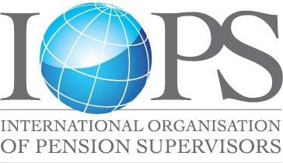

THE INTERNATIONAL ORGANISATION OF PENSION
SUPERVISORS (IOPS)

C/O
IOPS Secretariat
Email: Dariusz.stanko@oecd.org

IOPS Treasurer
Mr. Stephen Glenfield
General Manager, South West Region - Specialised Institutions Division
Australian Prudential Regulation Authority
Email: Stephen.Glenfield@Apra.Gov.Au

APPLICATION FOR MEMBERSHIP

Type of Membership:

Name of Organisation:

Address:

City: Country:

General Telephone number: Website:

Title and Name of Official Representative:

Direct Telephone number: E-mail:

Title and Name of Designated Representative:

Direct Telephone number: E-mail:

Membership status
Governing Members are entities responsible in whole or in part for the supervision of pension funds, plans, schemes or arrangements in a country or in the subdivision of a country.

Associate Members include:

- any governmental authority including any international authority, that is responsible in whole or in part for pension regulation or the establishment of pension policy and that has an interest in pension supervision, and

- solely at the invitation and discretion of the Executive Committee, any international governmental (or similar) organisation that has a direct, institutional interest in pension supervision.

Representatives

In the case of Governing Members, the official representative to IOPS must be the head of the supervisory authority. In the case of an integrated authority, the head of the unit most responsible for pension activities should be the official representative. Each Governing Member, however, may designate an individual who will act as its designated representative.

Associate Members must designate an official representative that will represent the Member at IOPS meetings and events. Each such official representative, however, may designate in writing an individual to act as their representative.

Procedures for becoming a member

- Interested parties should complete this application form and send it to the IOPS Secretariat and IOPS Treasurer.

- In cases where the application is subject to Executive Committee discretion, the application will be considered at a forthcoming Executive Committee meeting and the applicant advised of the outcome.
- Once your membership form has been received and approved, the IOPS will send a letter acknowledging membership. You will also receive an invoice for your membership fees, including methods of payment.

Membership fee for 2018

The IOPS membership fee for 2018 is levied in three bands according to the stage of economic development. The bands are based on the World Bank’s country classification (using per capita gross national income). Fees for Observers are the full €8,250.

- High-income economies €8,250

- Middle-income economies €5,500

- Low-income economies €2,750

_______________________

